**Problem1:**

Advantages: the CDF of processed image will be more smooth.

Disadvantages: the image will lose its characteristics.

**Problem 2:What value(s) of c give the best‐looking results? ( What happens to the image when the parameter is too high or too low?**

I tested it on Baboon.JPG.

When c equals to 1,the Image has best-looking results,which is like

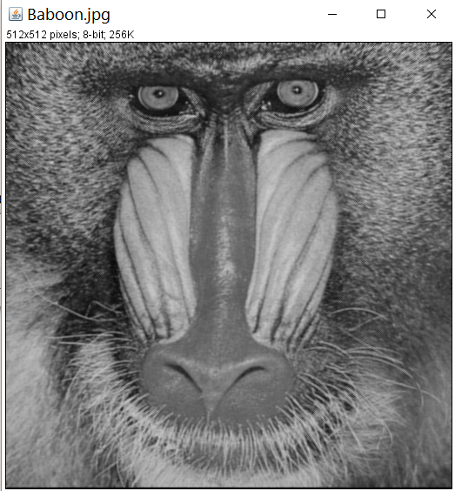

When the parameter is too high or too low, the image will be nearly all white which will be like

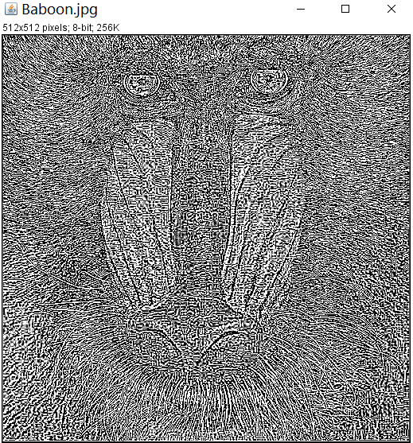

**Problem 3:**

**I: What value of w gives the most blurring? Explain why**

w = -1 gives the most blurring image ,because when w = -1, according to , the image will be which is Gaussian-blur .

**Ii: What value of w gives the most sharpening? Explain why**

w = 1 gives the most sharpen image, because when w = 1, according to  , the image will be which means it has negative effect on blurring image so, it is Gaussian-sharpen result.

**Iii :Run your filter on any image with the maximal amount of blurring (i.e. the w value from question 3.i and with σ = 10. Now try to reverse this by sharpening the image with the maximal amount of sharpening (the w fron question 3.ii) and the same σ = 10. Did you recover the original image? Why or why not?**

I can not recover the original image.The blurred image is like

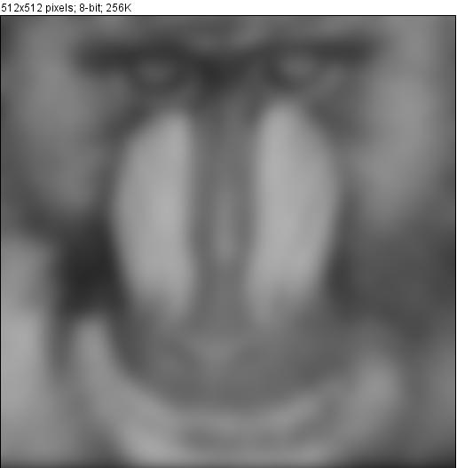

However, if I implement w = 1 sharpen, I can only get 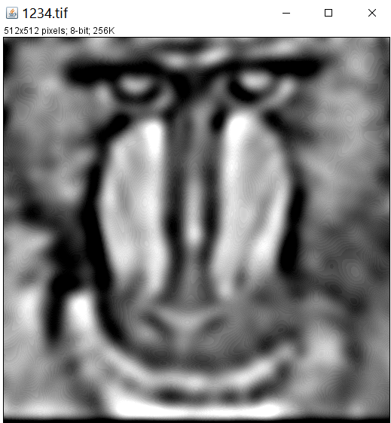

The reason that I can not recover it is that the neighbors’ pixel values have changed, and the processed point value is related to its neighbors. Also, the different neighbors have different weight.

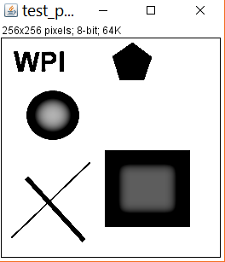

Description: The pixel value in the middle of a object with one pixel value will change. This is because the length of Gaussian filter is large and the distance between boundary is relatively not large enough. So the point will be effected by the value outside the boundary.

Problem 4:

i. Does this filter achieve the task of edge preserving filter (why or why not)?

I think this filter partially achieves the task in

ii. What can be done to improve the edge preserving properties of this algorithm?

The definition of edge is quiet simple which is the pixel value of processed image coordinate is 255.However, it is not quiet accurate, the value can be a range such as from 200 to 255. So we can improve the algorithm by adding the range of edge definition.

iii. Would it help to provide a scale-space feature to the algorithm, like the Canny edge detection?

It will help because the Canny operator will erase the noise which means can detect more precisely.